**Boondock Season 5: Release Date and other details!** 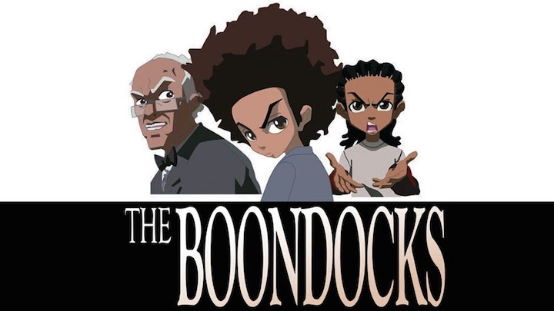

**The Boondocks**, an American sitcom grounded on "**The Boondocks**" by Aaron McGruder. It was created by Aaron McGruder for **Adult Swim** and Teletoon at Night. It's considered to be one of the top *television series* of 2010, garnered positive reviews and many awards.

**Boondock Season 5: Release Date**

The show was streamed on Adult Swim; releasing on November 6, 2005, and finishing on June 23, 2014, after four seasons with 55 episodes. *Season* 1 aired from November 6, 2005, to March 19, 2006. *Season* 2 was streamed from October 8, 2007, to March 23, 2008. ***Boondock Season*** 3 aired from May 2, 2010, to August 15, 2010. Then ***Boondock Season*** 4 was broadcasted from April 21, 2014, to June 23, 2014. On March 21, 2014, it was unveiled by *Adult Swim* that the ***Boondock Season*** 4 will be its last season. But later on, it was unveiled that *season* 4 will be created without the involvement of the creator of the series, the reason was the disagreement over the shoot and production schedule of the series. Thus, the sitcom concluded with 4 seasons.

Later in 2019, *Sony Pictures Animation* announced the "reimagining" of the *television series*. A reboot of the series was announced on June 12, 2019, with McGruder and John Witherspoon return before his death on October 29, 2019. The reboot of the series will stream on ***HBO Max*** in fall ***2020*** as announced by the creators on September 18, 2019. There'll be two seasons with a total of 24 episodes, 12 each.

**Boondock Season 5: Probable cast and Plot**

Since there's no official **release** on the storyline, characters, and the actors who'll be cast in the upcoming **season**. But we can anticipate the characters from the previous four seasons to reprise their roles. So, let's recap few characters who're likely to appear in **Boondock Season 5** and who appeared in the previous four seasons. 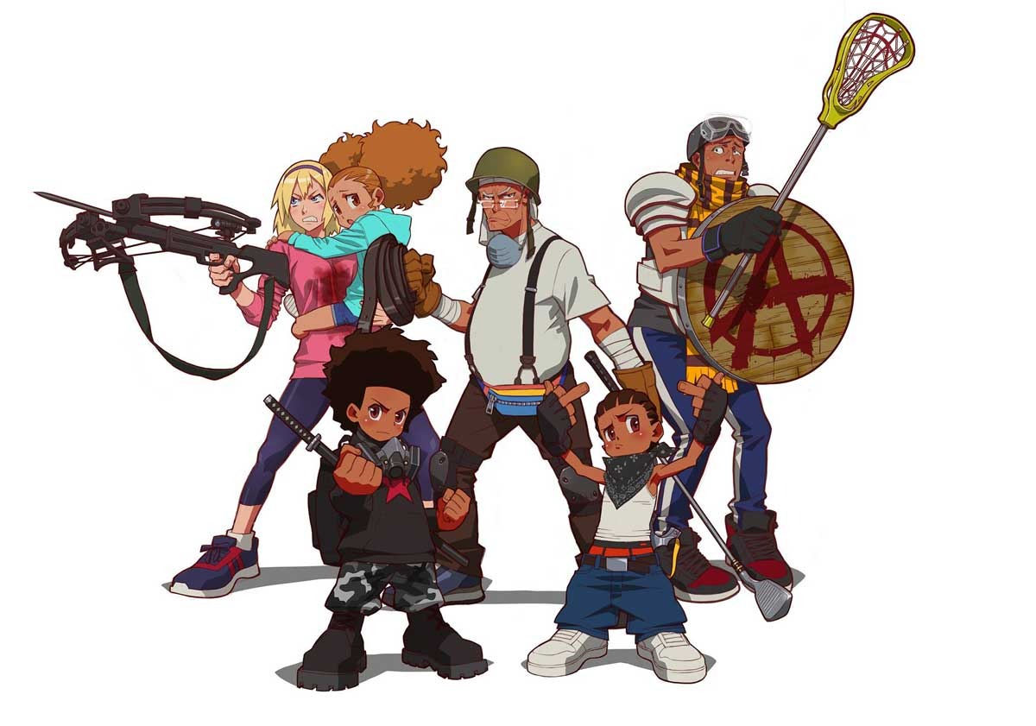

**Huey Freeman** voiced by Regina King- He's a 10-year old boy who's much more intelligent than children of his age but he's often underestimated by his brother and grandfather thinking that he's a fool to have so many dreams which are not generally pursued by the people. He's an avid promoter of social causes being heavily influenced by the theories of many left-wing social movements and social justice leaders. He's a great kung-fu fighter who lost only to few combatants. He rarely smiles, unlike other children.

**Riley Freeman** voiced by Regina King- He's Huey Freeman's 8-year old brother who's an ardent follower of Urban Gangster Rap/Hip Hop, unlike Huey who is derisive towards them. He's a very naughty and clever kid who maintains devotion towards Gangster Rap. The television series revolves around the mischievous actions of Riley who's repeatedly warned by his elder brother Huey. His action mainly revolves around his affection and craziness for Gangster Rap. He's a great street fighter. He also plays basketball.

**Robert Jebediah** Freeman aka Grandad voiced by John Witherspoon- He's the grandfather and legal guardian of Riley and Huey. Even though he loves his grandchildren unconditionally, sometimes he seems to be strict and punishes them for their mischievous actions, mainly Riley with Three Stooges- style corporal punishment. He was an ardent civil rights activist during his early days.

As, as we can see all the previous four seasons revolved around these three characters and the social issues raised by them, so we can expect Boondock Season 5 to be on the same track with another social issue and more mischievous actions of Riley and Huey.

**Boondock Season 5: Trailer**

There's no official **release** of ***Boondock Season 5 Trailer***, so till that time you can enjoy ***Boondock Season*** 4 ***Trailer***😊

https://www.youtube.com/watch?v=r6GRGEw7P9I